詹宗叡

[Dataset]: cifar10 cifar100 imagenet2012 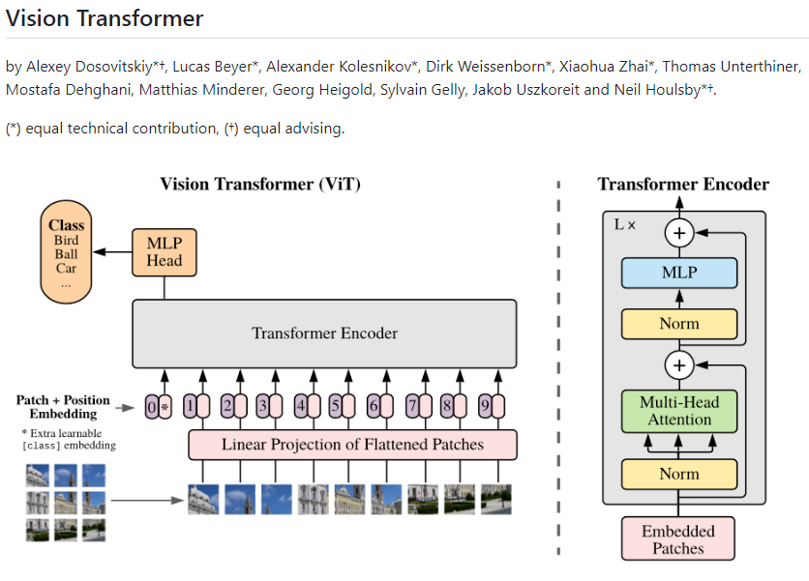

Fine-tuning a model
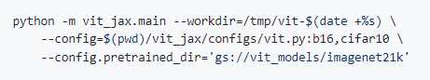
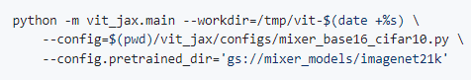

Available ViT models
